2. Data Understanding

2.1 Dataset Description
We use the MIT-BIH Arrhythmia Database, version 1.0.0, available from PhysioNet. The complete database contains 48 approximately half-hour ECG recordings from 47 people. Each recording contains two ECG channels sampled at 360 Hz.
Parameter | Complete Source Database | DS1 Analysis
Database Name | MIT-BIH Arrhythmia Database, version 1.0.0 | DS 1 Subset
Number of records | 48 | 22
Number of subjects | 47 | 22
Number of channels | 2 per record | 2(44 channel traces examined)
Sampling Frequency | 360 Hz per channel | 360 Hz per channel
Recording duration | 30.093 minutes | 30.093 minutes per recording
Annotation type | Expert-reviewed beat, rhythm, signal-quality and other event annotations in .atr files | Same annotations, restricted to DS1
ECG Leads available | MLII, V1, V2, V4, V5 | MLII, V1, V4 and V5 observed

The .dat files contain the ECG measurements, .hea files describe recording properties, and .atr files contain the reference annotations. Sampling frequency, channel names and recording duration were obtained from the DS1 headers. Class counts were calculated from the DS1 annotation files.
The analysed DS1 records were:
101, 106, 108, 109, 112, 114, 115, 116, 118, 119, 122, 124, 201, 203, 205, 207, 208, 209, 215, 220, 223 and 230.
The supplied DS1/DS2 membership was retained. All 48 recordings were checked for file availability, while waveform and annotation analysis was restricted to DS1. The results below describe raw data before model preparation.

2.2 Target Class
Final Class | Original Annotations included | Number of beats | Percentage (%)
N | “N,L,R” | 45834 | 89.85
S | “A,a,J,S,e,j” | 976 | 1.91
V | “V,E” | 3788 | 7.425
F | “F” | 415 | 0.813

Annotations outside these four classes were excluded from target-class counts. Eight unclassifiable beats marked Q were excluded because they have no reliable label among the required classes. A further 1,515 annotations described other events rather than N/S/V/F heartbeat targets. These remained available for rhythm and quality inspection.
Symbol | Category | Meaning | Count
+ | Non-beat annotation | Rhythm change | 616
! | Non-beat annotation | Ventricular flutter wave | 472
~ | Non-beat annotation | Signal-quality change | 289
| | Non-beat annotation | Isolated QRS-like artifact | 66
x | Non-beat annotation | Blocked P-wave | 58
Q | Excluded Beat | Unclassifiable beat | 8
[ | Non-beat annotation | Start of Ventricular flutter/fibrillation | 6
] | Non-beat annotation | End of Ventricular flutter/fibrillation | 6
“ | Non-beat annotation | Comment | 2

The supplied protocol excludes paced recordings 102, 104, 107 and 217. Paced-beat symbols / and f also fall outside the selected mapping. So, neither was observed in the analysed DS1 annotations. These are class-definition exclusions.

2.3 Exploratory Data Analysis
2.3.1 ECG Signal and Noise Example
The below figure shows reference-annotated clean, noisy and unreadable MLII intervals from recordings 101, 108 and 208. The clean interval has clearly distinguishable repeating beats. The noisy interval has an unstable baseline and additional fluctuations, while the unreadable interval shows substantial drift and poorly distinguishable beats.
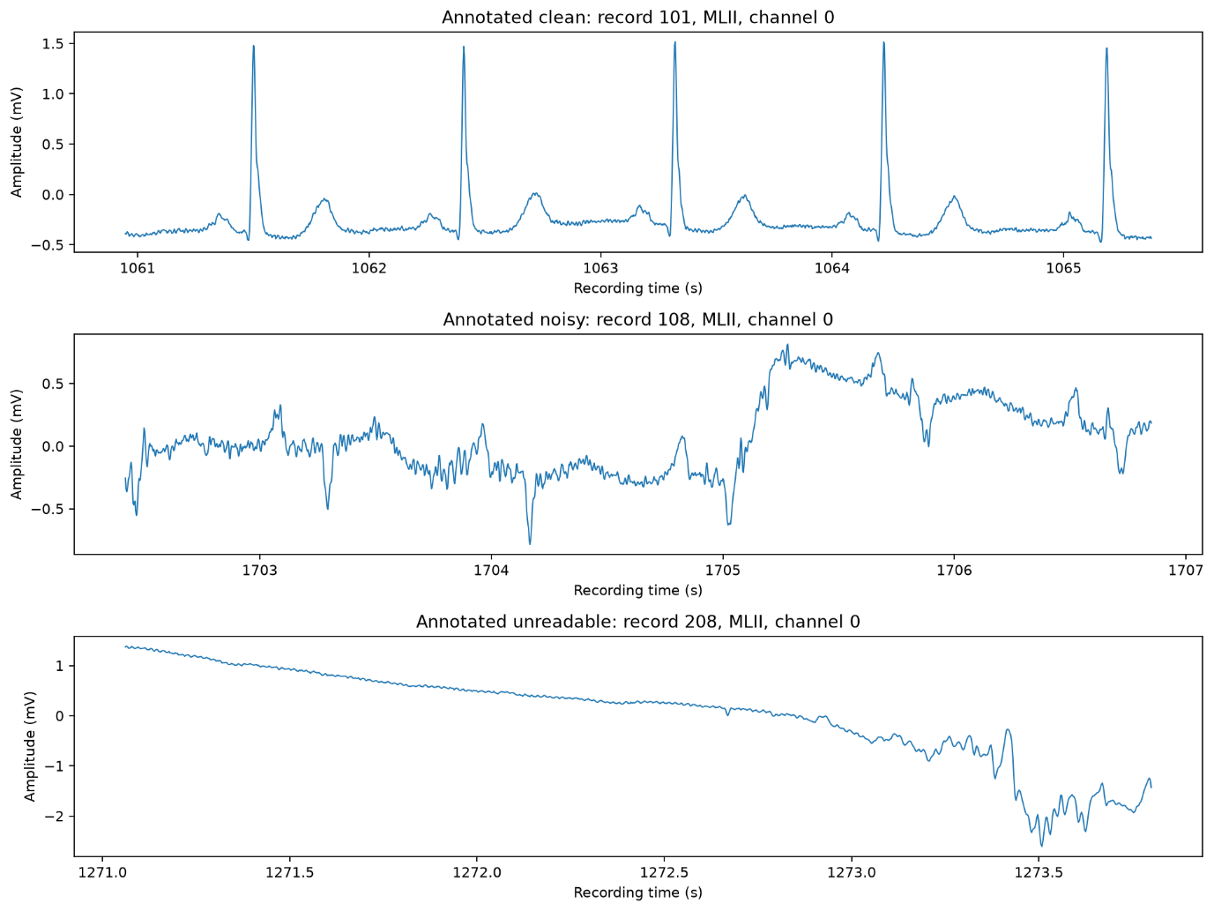
2.3.2 Example Heartbeat from each class:

Below figure shows one annotated example from each target class: N and S from recording 101, V from 106, and F from 108. MLII was selected by its header name to provide a consistent measurement view.
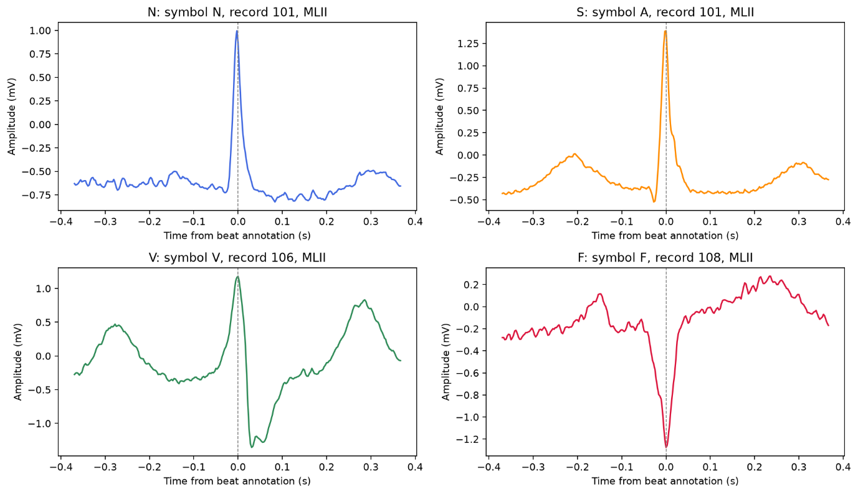

2.3.3 Class Distribution:
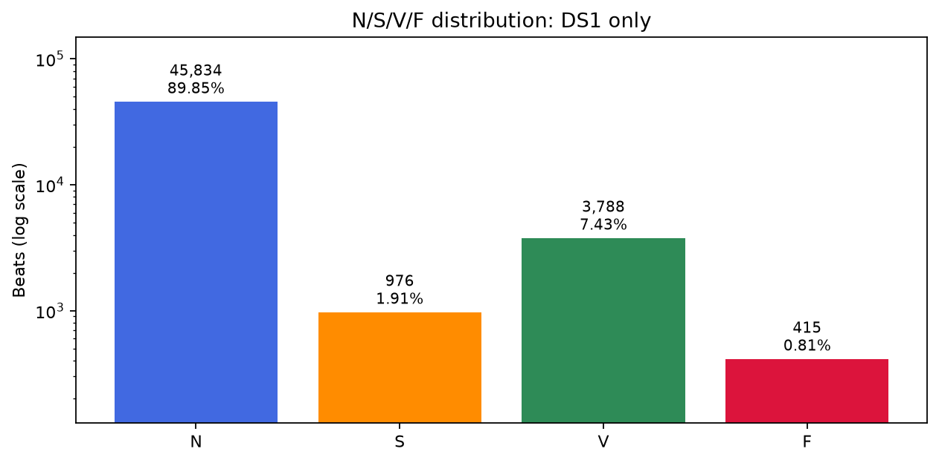

2.3.4 Subject/Record Distribution:
The below figure shows different numbers of retained beats across the approximately equal-duration recordings. Counts range from 1,619 in recording 124 to 3,363 in recording 215.
The record and subject distributions match within DS1 because each analysed recording belong to a different person. Subject key 201_202 identifies the person whose second recording lies in DS2 and only record 201 contributes to these DS1 statistics.
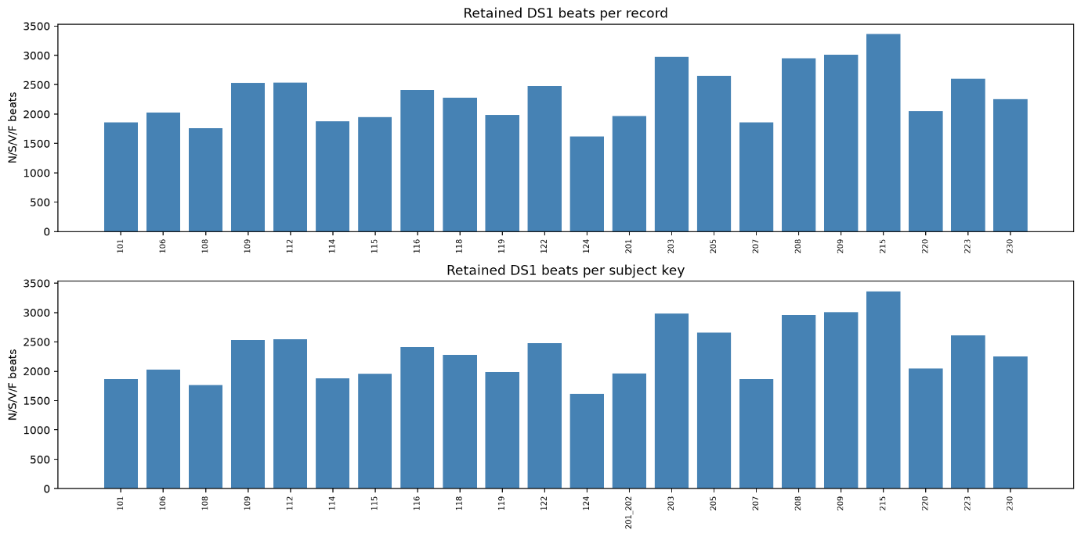
Below figure shows that class availability also varies between recordings
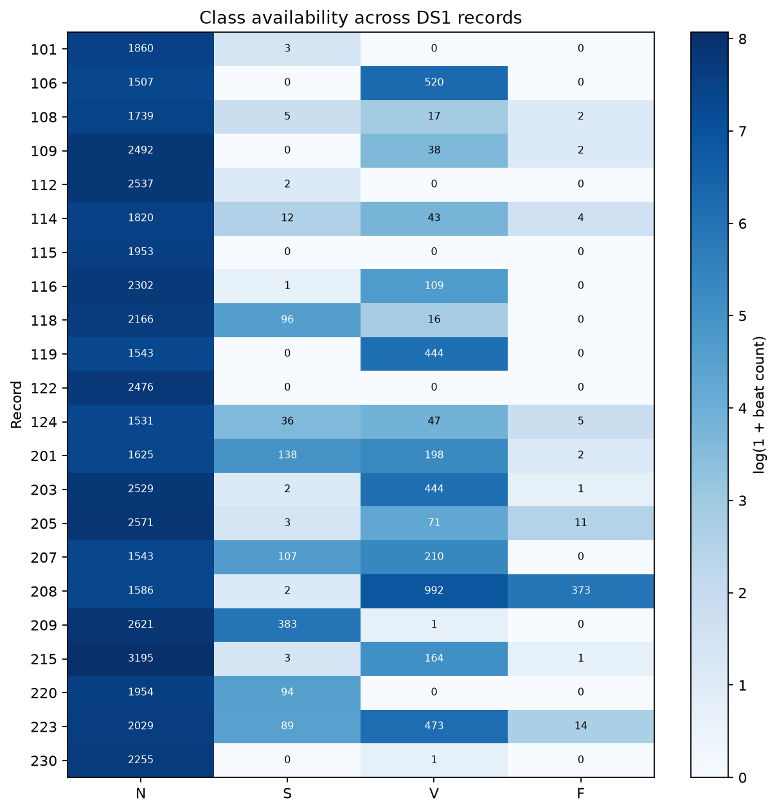

2.3.5 Signal Amplitude Distribution
Below figure displays amplitude histograms for the observed leads. We sampled 5,000 values from each record/channel using random seed 42, giving 220,000 plotted measurements. Histogram widths were calculated using the data-dependent Freedman–Diaconis rule.
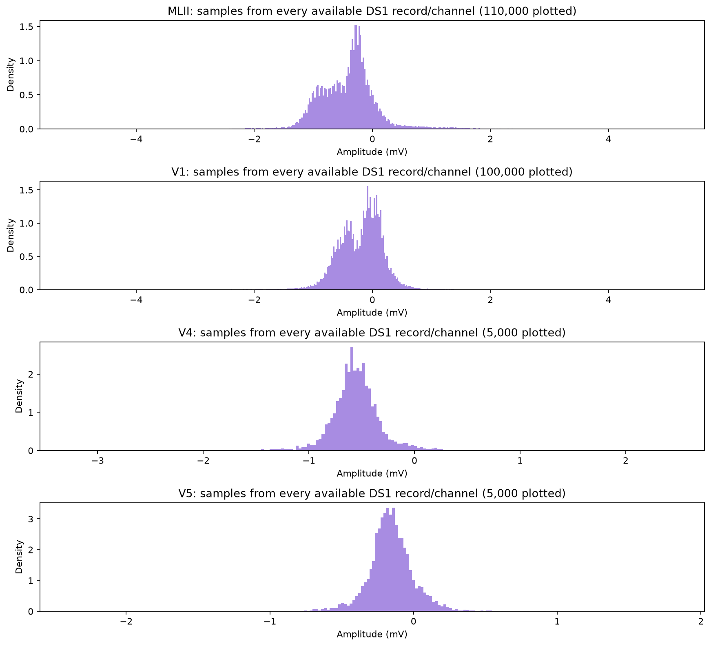

2.3.6 Examples of Noisy ECG
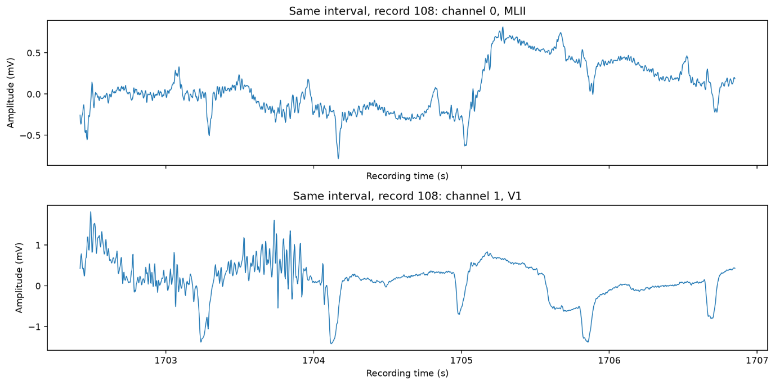

2.4 Data Quality
Quality Check | Result
Successfully read DS1 recordings | 22
Channel traces examined | 44
Signal Read errors | 0
Missing values represented by NaN | 0
Infinite sample values | 0
Header checksum mismatch | 0
Samples at or beyond computed ADC limits | 1635
Out of range annotation positions(DS1) | 0
Out of order Annotations (DS1) | 0
Duplicate beat positions (DS1) | 0

Extreme Amplitudes and potentially corrupt segments:
Observed amplitudes ranged from −5.120 to 5.115 mV. These extrema occurred in MLII from recording 116 and V1 from recording 223.
The 1,635 samples flagged at possible ADC limits identify candidate clipping regions. No channel had an exact constant digital run lasting at least 0.7389 seconds. Large jumps and constant digital runs were also measured. Recording-limit values, sudden changes and repeated samples are quality indicators, and do not independently prove signal corruption. No automatic deletion was based on these checks.
Class Imbalance:
‘N’ represents 89.85% of retained DS1 beats. A rule that assigns every retained DS1 beat to N would therefore match 89.85% of the labels while identifying none of the minority classes. This supports the use of macro-F1 and per-class recall described in Section 1. The concentration of F beats in recording 208 additionally limits the range of subjects represented by that class.
Difference between recordings and channels:
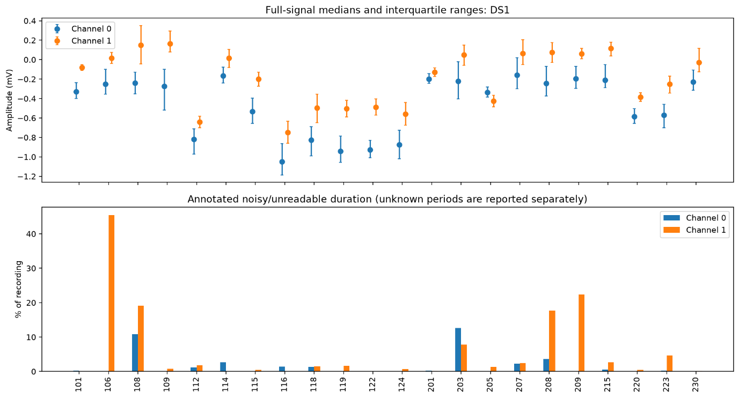
The above figure compares median amplitudes, the middle 50% of sample values and annotated noisy/unreadable duration for each channel. Median offsets, amplitude spread and quality coverage vary between recordings and between their two channels.
For example, recording 106 has a much larger annotated noisy/unreadable fraction in channel 1 than in channel 0.

2.5 Leakage Analysis
Randomly splitting individual heartbeats from the same person between training and testing can produce misleading results. These beats share characteristics of that person’s ECG and recording conditions. Neighbouring beats can also be highly similar, and extracted windows may share signal samples. A model can therefore exploit familiar patterns in the test group, making its performance appear better than its performance on previously unseen people. Multiple beats from one person are not equivalent to the same number of independent people.
Our evaluation design follows the supplied whole-record DS1/DS2 partition. DS1 is used for development, and DS2 is reserved for final testing. All heartbeats from a recording belong to its assigned group instead of being randomly distributed between development and testing. This prevents the same recording from supplying beats to both groups. The development design also separates training and validation by recording, the EDA notebook itself does not create these model-training splits.
Leakage could also arise from using test data to select model or preprocessing settings, fitting normalisation on combined training and test data, or distributing original and augmented versions of a beat across groups. The EDA does not perform fitted normalisation, training augmentation or model training.
The supplied DS1/DS2 partition nevertheless contains one documented subject overlap: recordings 201 and 202 belong to the same person, with 201 assigned to DS1 and 202 to DS2. A model trained on 201 and evaluated on 202 would therefore encounter a familiar person despite receiving a different recording. The supplied partition separates recordings but is not fully subject-independent. Our current analysis identifies this limitation, restricting access to DS2 alone does not eliminate it.

